How Certification Meets the
Interests of Consumers and Producers
Kiel, 17 October 2019

Most products that are offered to consumers in the retail market today are produced within complex value chains that pass across many companies, industry sectors, countries, and even continents with divergent intensities of national regulation cornerning sustainable use of resources. At the same time, business relationships along the value chain and competition on markets are controlled by cost and price competition. A particular feature of global trade flows is their ability to use cost advantages in the availability of natural and human resources for the production of goods. Lax environmental regulations lower the cost of goods with strong environmental effects, as low social standards give labor-intensive products a cost advantage.

These cost advantages determine price advantages and thus determine which goods are most demanded by importers and eventually consumers. However, cost and price advantages do not always reflect the true cost of the resources used. Economists have developed the concept of “external effects” or externalities to capture this effect. A negative externality exists if an economic activity such as farming creates a side effect that is not reflected in the production cost of the producer. One of the most prominent examples is the establishment of a farm in a previously forested area. The greenhouse gas (GHG) emissions caused by deforestation and their damages to the global climate system are not included in the cost of the farming, i.e. they are external to the farming activity. As a consequence, the private costs of a farm product are smaller than their actual societal costs.

In order to bring in line private and societal costs, government intervention is the usual approach. Such externalities need to be internalized by government policies. The most efficient way of doing this is to charge producers the external costs of their activities as this is done in the European Emissions Trading Scheme (EU-ETS) where the operators of large power plants need to purchase emission rights for the emissions they are causing. A different approach has been established within the European Renewable Energy Directive (RED) where a certain share of biofuels is required in the transport fuel market. Germany has in the meantime moved to GHG-quota for biofuels that offers more transparency about the actual GHG-savings and thus creates incentives for producing biofuels with the lowest possible fossil fuel inputs and the least GHG emissions. Such an emissions-based system is economically more efficient and ecologically more effective than a quantity-based system where the actual GHG savings are not taken into account.

Externalities are caused at the local level when emissions are generated, or natural and societal resources are overused or destroyed. They can have impacts far beyond the points of origin, from national to global scale. Unsafe and unethical working conditions destroy the social capital of a society; child labor precludes future economic growth because of a lack of education of the next generation. Overuse of water resources or land-use practices threatening or destroying biodiversity reduce the natural capital of a nation. GHG emissions constitute typical global externalities.

The UN passed in 2015 the 2030 Agenda for Sustainable Development with 17 Sustainable Development Goals (SDGs). The content of many of these SDGs refers to environmental and social externalities. Achieving the SDGs requires their control through successful implementation of appropriate measures. It is the foremost duty of national governments to internalize these externalities, but global externalities also need international cooperation.

Unfortunately, two issues prevent a globally agreed approach towards the SDGs. One is the fact that in many countries there is a lack of regulatory intervention for controlling local and – even more so – global externalities. In cases where such policies exist, implementation challenges and law enforcement problems remain thus making regulatory measures ineffective. The other aspect concerns the fact that internationally differing societal values exist towards some of the external effects. Countries may prefer economic growth and the expansion of agricultural areas for achieving or maintaining low food prices rather than protecting biodiversity and carbon stocks of forest areas.

In both cases, there is a conflict between the interests of consumers for products that are produced sustainably and the interests of some producers in offering the most competitive prices while ignoring the externalities this causes. At the same time, companies serving markets with an interest in sustainable products may want to manage sustainability risks along their often complex and multifaceted supply chain and seek measures to ensure that their products are sustainably produced and free of externalities.

This is where certification comes in!

Certification of supply chains can ensure that a product containing minimal environmental and social external effects meets the interests of consumers and producers in delivering and consuming sustainable products. By making sure that only suppliers of sustainably produced feedstocks are allowed in the supply chain, and that all processes along the supply chain meet similar sustainability requirements, a sustainable market niche is created, even if appropriate and comparable national sustainability requirements along the different stages of the supply chain do not exist.

Currently, we are observing only a limited market for such products where certification assures sustainability. Many voluntary labels use certification for social aspects such as fair-trade labels or for sustainable forestry. The most elaborate system is provided by the Renewable Energy Directive of the EU where incentives have been created to produce sustainably produced biofuels, although social sustainability aspects are not explicitly included. Nevertheless, some certification systems such as ISCC (www.iscc-system.org) also require proof of social sustainability as well. These systems have improved production conditions, environmental preservation, and social aspects, but only inside the production units and possibly in the vicinity of the places where certification is applied. This is, e.g., illustrated by the ISCC Impact Report 2018.

It is clear that – by the nature of most voluntary approaches - certification does not lead to a large scale move towards more sustainable production systems and a reduction in environmental and social externalities. Unless the demand of consumers in sustainable products and that of companies in sustainable supply chains increases tremendously, certification will not be the solution to meeting the SDGs.

Currently, most agricultural products are not subject to voluntary or obligatory certification systems. The highest coverage has coffee where an estimated 25 to 45 per cent of cultivated area are controlled by some certification scheme.

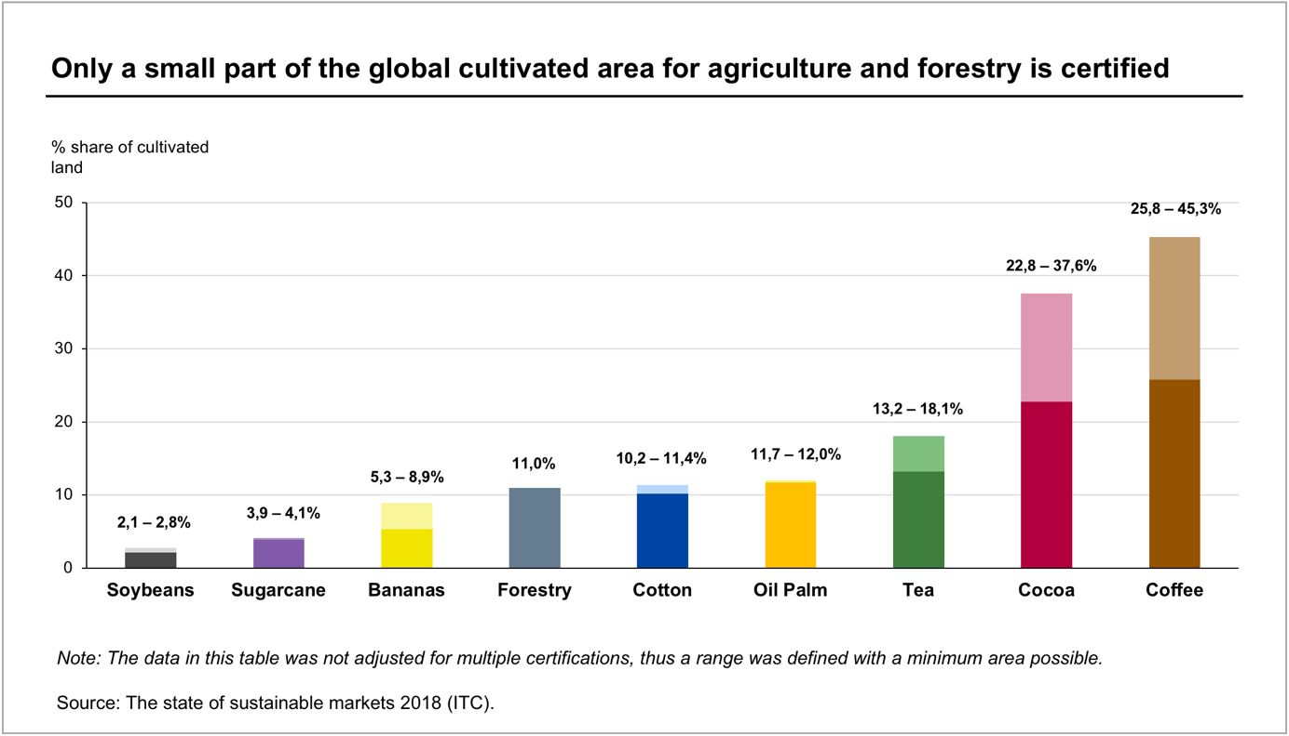
Figure 1: Certified share of cultivated land (minimum – maximum %)

Despite the currently low shares of certified agricultural activities, certification sets examples in terms of the feasibility of moving towards sustainable practices, in terms of the administrative feasibility of controlling and maintaining transparent supply chains for a large number of different products with very diverse supply chains. The widespread belief that certification is too complicated and too expensive has been refuted by the current practice. Of course, there are certification systems that are rather complicated and impose substantial costs on suppliers in the chain. However, this does not need to be the case if the system is efficiently managed and uses up-to-date information technologies. A large number of agricultural activities is performed by smallholder farmers which are often considered to be difficult to regulate concerning some of their unproductive and unsustainable production practices. Even there, the latest developments in the certification systems have demonstrated that this is possible with advanced but easy to use IT-technologies and simple smartphone applications for smallholder farmers. Countries like Malaysia and Indonesia are in the process of including small farmers into their sustainability programs with the help of technologies developed for certification systems.

One of the success stories of the RED of the EU and the certification procedures were and still are the incentives provided for improving the GHG balance of bioenergy products, especially biofuels. Since no international incentive mechanisms for reducing emissions in bio-based value chains exists, the RED’s blending requirements and its implementation through certification have been dominant drivers for improving the GHG balance of bioenergy. In recent years the GHG savings per unit of biofuel produced have improved continuously. Figure 2 shows how the GHG savings in the German biofuel market have risen in the last few years due to the incentives created by moving from an energy-based mixing requirement to a GHG accounting system.

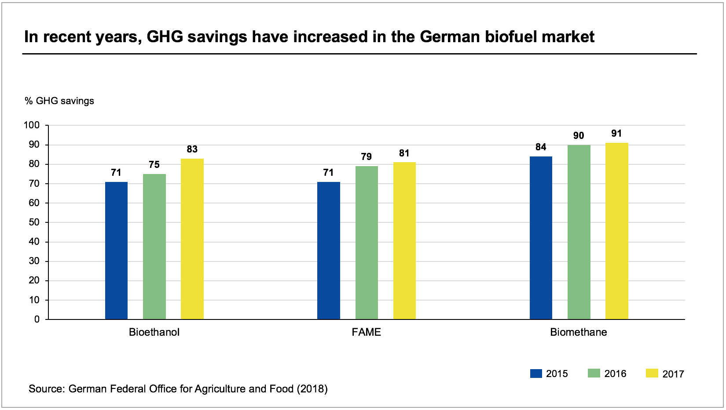
Figure 2: GHG savings of biofuels compared to fossil fuels (German market)

But it is not only consumers that are satisfied by being able to fulfill their demand for sustainable products. Farmers who have chosen to become certified not only benefit from price premia paid for certified products, they also experience numerous non-monetary benefits for their livelihood. Figure 3 summarizes some of the findings from the introduction of sustainability certification for coffee farmers in Colombia. They show that is not only consumers who will have their demand met, but rural communities can equally benefit from the side effects of moving towards a more sustainable production system. “The advantage of certification is the impact it has on the farms, as living conditions of farmers have improved. They are proud to be certified.” says Juan Camilo Ramos Mejia, FNC.

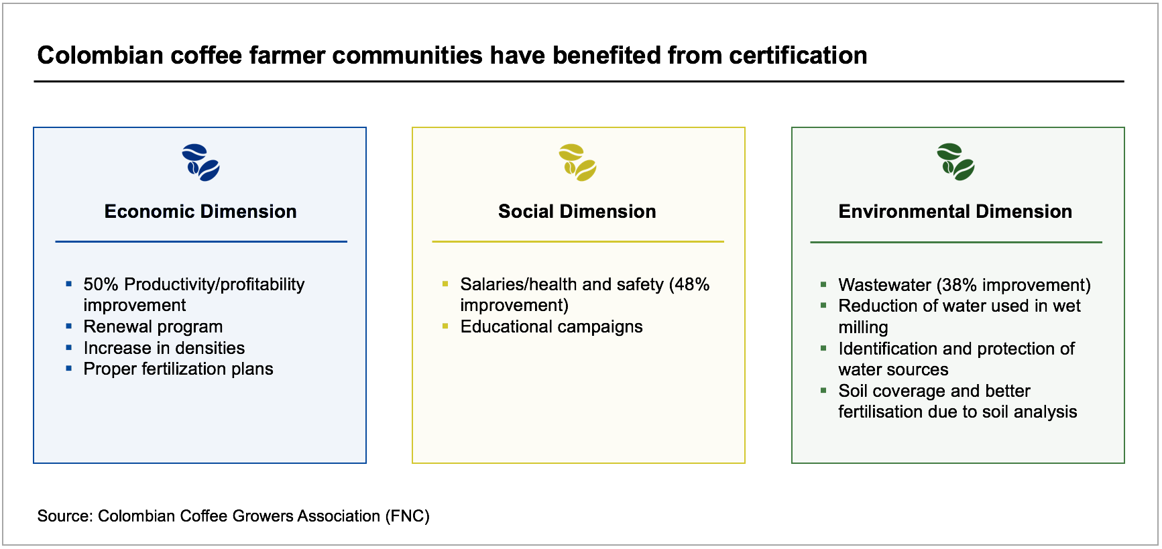
Figure 3: Impact of certification on the sustainability of rural communities
To sum up: Certification already provides important informational services to consumers interested in buying sustainably produced goods with a small environmental impact and acceptable social conditions, the first dividend of certification! It also creates incentives as well as information to producers for offering such sustainable feedstocks, supply chains, and final consumption goods. In most cases, this leads to improved environmental conditions but also to higher, more secure incomes and thus more social sustainability, the double dividend of certification!

Therefore, the market segments that supply sustainable products that are incentivized and controlled by certification along the supply chain have had an important impact within their segments and have induced more sustainable production practices throughout the world with thousands of farmers and processing companies involved. Certification has tremendous leverage. Despite these developments, critics often claim little impact by comparing certified products to the overall market size. This is not an appropriate criterion in markets with voluntary certification. Nevertheless, it is argued that “Beyond Certification” is a new strategy and a project-based approach by going to the farms and communities to tackle some of the complex environmental and social problems directly. This strategy may supplement certification, but it would not offer the geographical and market leverage which a rule-based system of incentives through certification offers. Or, if approached on the same scale, it would require a large amount of personal resources in order to achieve the same coverage as a certification system. For example, ISCC alone has issued more than 23,000 certificates in over one hundred countries. Getting the same impact by conducting projects all over the world seems hardly feasible.

While certification today covers only a small proportion of global markets, it provides a blueprint for expanding the procedures developed so far to a much wider range of market participants. This will require that not only market demand-driven voluntary certification is established, but that regulatory requirements are put in place to enforce more sustainable supply chains. The current drive towards more effective systems of carbon pricing through CO₂-taxes or an expansion of emission trading schemes beyond the large emitters such as power plants will create incentives for more climate-friendly production and logistic processes. Introducing such policies requires information flows for which certification has set the appropriate procedures.

Certification has helped to create numerous sustainable supply chains for niche markets providing first steps towards a sustainable production system. Its contribution to moving towards sustainability and for meeting many of the SDGs is proof of feasibility. It is now up to the appropriate governmental institutions to use these insights in the process of imposing the appropriate incentives for reducing external effects and for moving towards a sustainable global economy. The double dividend of certification for consumers in being able to buy sustainable products and to producers in obtaining higher productivity and incomes at lower environmental and social costs is established in niche markets. It can be expanded beyond the current market segments through appropriate national or multilateral sustainability requirements.

Prof. Gernot Klepper Ph.D.
Kiel Institute for the World Economy

https://www.iscc-system.org/about/impact-report-2018/

